Supporting Information for:

Sometimes pulses just have to be perfect – an example based on the measurement of amide proton transverse relaxation rates in proteins
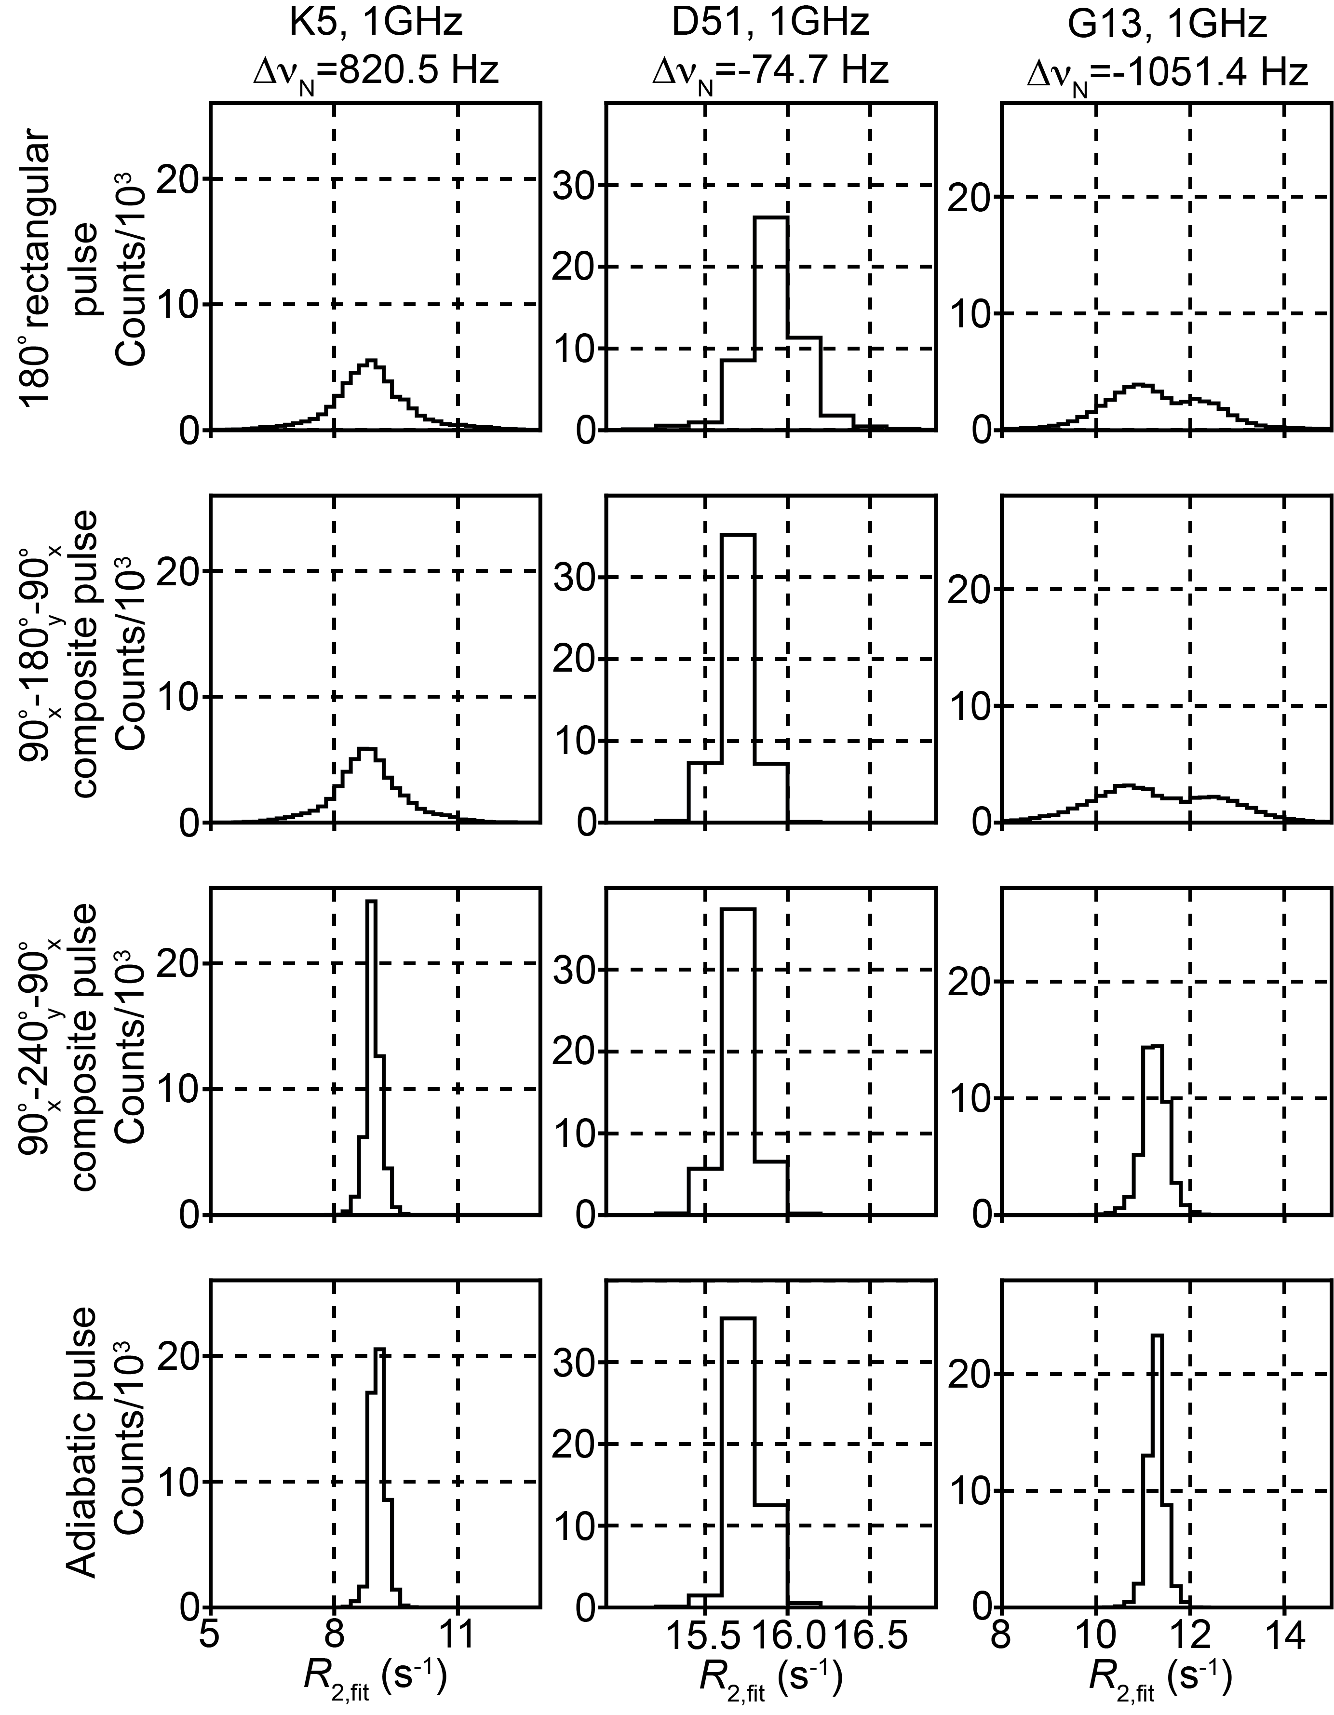

Supplementary Figure 1. Histograms of fitted R₂ values (R_{2,fit}) obtained by iteratively fitting randomly sampled experimental data. Eight time points were randomly sampled without replacement from the experimental decay curves in Figure 1. The process was repeated 50,000 times and the histogram of the fitted R₂ values (R_{2,fit}) is plotted.

Supplementary Figure 2. Comparison between experimental and simulated ¹H^{N} R₂ profiles with ¹⁵N 180° rectangular pulses. (A) (top) Experimentally measured decay profiles of the ¹H^{N} transverse magnetization of K5 (left), D51 (center), and G13 (right) in a [U-¹⁵N,²H]-labeled protein L sample measured with rectangular ¹⁵N inversion pulses, 23.5 T, 25 ºC. Points are experimental data while solid lines are the best fits to an exponential decay function. See Fig. 1B legend in the main text for the details. (bottom) Decay profiles of ¹H^{N} magnetization simulated using the ¹⁵N and ¹H^{N} offsets of K5 (left), D51 (center), and G13 (right). The simulations were based on the scheme shown in Fig. 1A of the main text, with magnetization evolving from H_{x} (at the start of the sequence) to 2H_{y}N_{z} (at the end) by setting δ to 4.8 ms (~ $\frac{1}{2J_{HN}}$). In the simulations, the ¹H^{N} carrier was set to be on-resonance with water (~4.70 ppm), and the ¹H^{N}-selective REBURP pulse (1.36 ms, maximum B₁ field strength of 4.6 kHz at 23.5 T) was applied at +3250 Hz off-resonance (centered at 7.95 ppm) by linearly shifting the pulse phase. ¹⁵N 180° rectangular pulses were applied with an rf field strength of 5.95 kHz (90° pulse length of 42 μs). Relaxation rates were calculated as described in Materials and Methods of the main text assuming an isotropic tumbling time of 5 ns. Per-residue contributions from external proton spins and amide-water exchange were included by an additional relaxation term, λ_{H}, which was added to the calculated auto-relaxation rates for transverse ¹H components (H_{x}, H_{y}, 2H_{x}N_{z}, 2H_{y}N_{z}, 2H_{x}N_{x}, 2H_{x}N_{y}, 2H_{y}N_{x}, and 2H_{y}N_{y}) to obtain agreement between experimentally measured and fitted rates from simulated decay profiles. The λ_{H} values were set to 2.4, 8.9, and 4.7 s⁻¹ for K5, D51, and G13, respectively.

