Supplementary Information

Practical considerations for the measurement of near-surface electrostatics based on solvent paramagnetic relaxation enhancements

Atul Kaushik Rangadurai, Yuki Toyama, and Lewis E. Kay

Supplementary Table 1. Percentage of the reduced form of spin labels.
Compound | Source | Percentage of the reduced form
3-aminomethyl PROXYL  (CAS: 54606-49-4) | Sigma-Aldrich | ~ 0
3-carbamoyl PROXYL  (CAS:4399-80-8) | Sigma-Aldrich | ~ 0
3-carboxy PROXYL  (CAS: 2154-68-9) | Sigma-Aldrich | ~ 0
3-cyano PROXYL  (CAS: 2154-70-3) | Sigma-Aldrich | ~ 0
3-hydroxymethyl PROXYL  (CAS: 27298-75-5) | Toronto Research  Chemicals | ~ 0
3-methoxycarbonyl PROXYL  (CAS: 46247-54-5) | Kyoto Spinlabo | ~ 0
4-amino TEMPO  (CAS: 14691-88-4) | Toronto Research Chemicals | 10
4-oxo TEMPO  (CAS: 2896-70-0) | Sigma-Aldrich | 1.9
4-carboxy TEMPO  (CAS: 37149-18-1) | Sigma-Aldrich | 29.9
The net molar concentration of each co-solute molecule ([Net]) was measured by using ¹H 1D NMR as described by Iwahara and co-workers [1] in the presence of 50 mM ascorbic acid to reduce the radical. The concentration of the reduced form of the compound ([Reduced]) prior to reduction was estimated by following the same procedure but without the addition of ascorbic acid, assuming that the signals from the oxidized form are broadened beyond detection due to strong intramolecular PREs. The reported values are the ratios of the two concentrations, [Reduced]/[Net]. For all PROXYL derivatives, the ¹H peaks corresponding to the reduced form in the samples without ascorbic acid were too small to be reliably quantified, thus, the percentage of the reduced form is reported as ~ 0 (within the detection limits of the 1D NMR experiments).

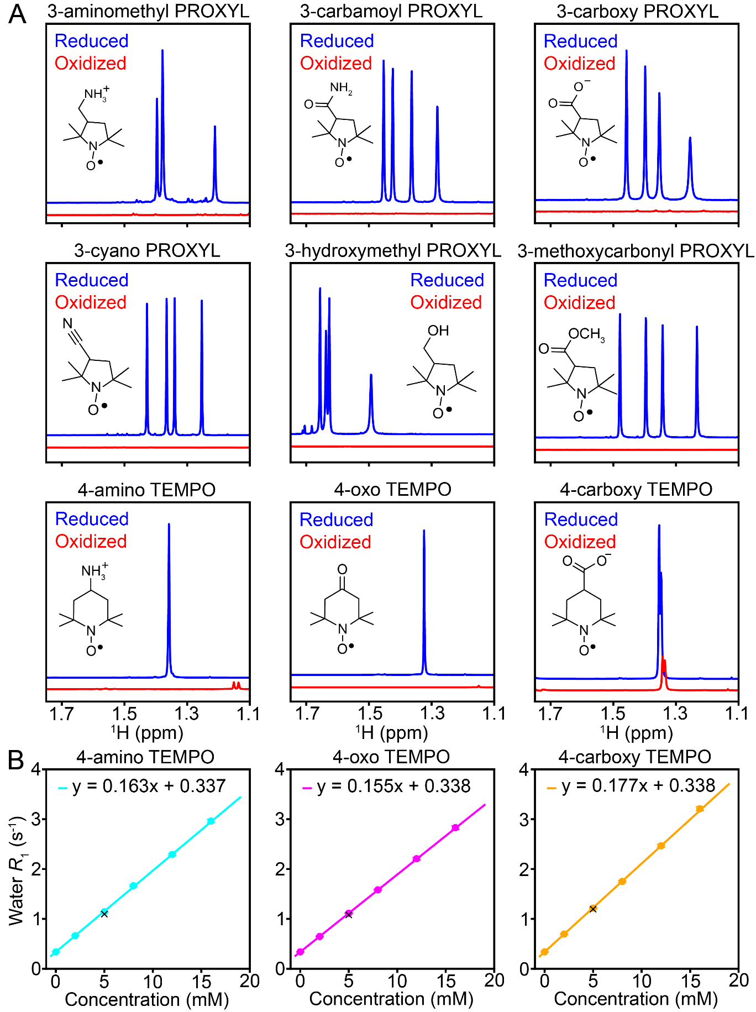

Supplementary Figure 1. (A) ¹H 1D spectra of the methyl region of each co-solute before (Oxidized, red) and after (Reduced, blue) reduction with 50 mM ascorbic acid. Samples also contained 10 mM DMSO so as to enable measurement of the concentration of the co-solutes using an approach described by Iwahara and co-workers [1]. All spectra were collected in 25 mM MES buffer, 3% D₂O at 25 °C and 500 MHz, apart from those for 3-cyano PROXYL, which were collected at 800 MHz, and 3-hydroxymethyl PROXYL, which were collected at 50 °C. The data for 3-hydroxymethyl PROXYL were collected at higher temperature to reduce exchange broadening effects. The NMR spectra were measured with a ¹H 1D sequence with solvent suppression using the excitation sculpting method [2]. Also shown in the inset are the chemical structures of the oxidized form of each spin label. (B) Water ¹H R₁ as a function of the concentration of added TEMPO derivatives. The water ¹H R₁ rate was measured using a saturation recovery scheme with a small flip angle (< 15 °) pulse for readout, as described previously [3]. All measurements were performed in 25 mM MES buffer pH 5.5 containing 3% D₂O and at 25 °C. Points denote the experimental data, while the solid line is the best fit of the data to a straight line. ‘x’ denotes the water R₁ rate in a sample comprising 300 μM CAPRIN1 in 25 mM MES buffer pH 5.5, 3% D₂O and at 25 °C, where each co-solute was added from the stock solution to make it 5 mM as a paramagnetic form.

References

[1] B. Yu, C.C. Pletka, B.M. Pettitt, J. Iwahara, De novo determination of near-surface electrostatic potentials by NMR, Proc Natl Acad Sci U S A, 118 (2021).
[2] T.L. Hwang, A.J. Shaka, Water Suppression That Works. Excitation Sculpting Using Arbitrary Wave-Forms and Pulsed-Field Gradients, J Magn Reson Series A, 112 (1995) 275-279.
[3] Y. Toyama, A.K. Rangadurai, J.D. Forman-Kay, L.E. Kay, Mapping the per-residue surface electrostatic potential of CAPRIN1 along its phase-separation trajectory, Proc Natl Acad Sci U S A, 119 (2022) e2210492119.

