Supplementary Information

Structural basis for the stabilization of

amyloidogenic immunoglobulin light chains by hydantoins

Nicholas Yan^{a,†}, Diogo Santos-Martins^{b,†}, Enrico Rennella^{c}, Brittany B. Sanchez^{d}, Jason S. Chen^{d}, Lewis E. Kay^{c,e}, Ian A. Wilson^{b, f}, Gareth J. Morgan^{g,h}*, Stefano Forli^{b,}*, Jeffery W. Kelly^{a,f}*

ªDepartment of Chemistry, The Scripps Research Institute, La Jolla, CA 92037
^{b}Department of Integrative Structural and Computational Biology, The Scripps Research Institute, La Jolla, CA 92037
^{c}Departments of Molecular Genetics, Biochemistry and Chemistry, The University of Toronto, Toronto, ON, Canada M5S1A8
^{d}Automated Synthesis Facility, The Scripps Research Institute, La Jolla, CA 92037
^{e}The Hospital for Sick Children, Program in Molecular Medicine, 555 University Avenue, Toronto, ON, Canada M5G1X8
^{f}The Skaggs Institute for Chemical Biology, The Scripps Research Institute, La Jolla, CA 92037
^{g}Section of Hematology and Medical Oncology, Department of Medicine, Boston University School of Medicine, Boston, MA 02118
^{h}The Amyloidosis Center, Boston University School of Medicine, Boston, MA 02118

† identifies co first-authors
* identifies corresponding authors: gjmorgan@bu.edu; forli@scripps.edu; jkelly@scripps.edu

Table of Contents
Materials and Methods Pages S2 – S3
Supplementary Figures (Table S1; Figures S1 – S6) Pages S4 – S10
Supplementary References Page S11

Materials and Methods
Recombinant human LCs were expressed in E. coli as inclusion bodies, refolded and purified as previously described [1, 2]. Compounds 7 and 8 were purchased from Enamine (Monmouth Jct., NJ) as mixtures of stereoisomers.
Computational
Molecular docking was performed with Autodock Vina 1.1.2. The input files of the hit molecules were prepared using OpenBabel versions 2.3.2. This process includes generating 3D coordinates, atom typing and deciding which bonds can be rotated during docking. We inspected and manually edited 3D coordinates of the small molecules using Avogadro 1.1.1. The model for the light chain dimer was identical to PDB entry 6MG5, which was not yet published when the docking was performed. A single explicit water was kept in the receptor, corresponding to water 405 in chain A of PDB entry 6MG5. This water does not make hydrogen bonds with any of the hit molecules. Atom typing, hydrogen addition and input file preparation for the light chain was done by OpenBabel according to the standard preparation protocol [3]. The search space for docking was a cube of 25x25x25 angstroms, centered at x=0, y=-22 and z=35 Å, defined relative to PDB entry 6MG5.
Analytical ultracentrifugation (AUC)
Small molecule in 1% DMSO vehicle or vehicle alone was added to 10 µM WIL-FL C214S in PBS to a final concentration of 100 µM. Sedimentation velocity experiments were recorded on a Beckman XL-1 analytical ultracentrifuge at 50,000 rpm at 20 °C. Sedimentation was measured by absorbance at 280 nm. Data were processed using SedFit [4].
Solution nuclear magnetic resonance (NMR)
NMR spectra were measured on a Bruker Avance III HD 14.1 T spectrometer equipped with a cryogenically cooled, x,y,z pulse-field gradient triple-resonance probe. Spectra were recorded at 37° C at 50 μM LC concentration in 50 mM BIS-TRIS pH 6.4, 1 mM EDTA, 10% D₂O, 1% DMSO vehicle and 0.02% Pluronic F-127 detergent. The concentration of small molecule was 100 µM.
Crystallography and structure determination
Crystals of JTO-FL were grown via sitting-drop vapor diffusion (CrysChem plates, Hampton Research, Aliso Viejo, CA) using a precipitant consisting of 20% PEG 3350 and 0.25 M NH₄H₂PO₄ at 23 °C. Drops were prepared by adding 2 µL precipitant to 2 µL protein (200 µM JTO-FL in PBS) without mixing. The reservoir contained 500 µL precipitant. The wells were sealed with clear tape, and diffraction-quality plate-shaped crystals appeared overnight, reaching a maximum size in 3 days. To generate JTO-FL•8 complexes, a stock solution of 100 mM ligand in DMSO was first diluted 10-fold in precipitant. Thereafter, 0.25 µL of the ligand suspension was added to drops containing crystals, the plate resealed, and incubated at 23 °C for at least 3 days. Crystals were harvested and cryoprotected by brief immersion in a 1:3 solution of glycerol:precipitant with 1.25 mM ligand (1.25% DMSO), then flash cooled in liquid nitrogen. Diffraction data were collected at beamline 5.0.3 at the Advanced Light Source, Lawrence Berkeley National Laboratory. Structure solution and refinement was carried out as previously described for JTO•1 [5]. The refined model was deposited to the Protein Data Bank under accession code 6W4Y.
Chiral resolution
The enantiomers of 8 were separated on a Waters UPC2 SFC with a Daicel IA column (3 µm, 4.6 x 250 mm) under isocratic conditions (4 mL/min, 30% MeOH / CO₂, 1600 psi backpressure) at 30 °C. The enantiomers were detected by UV absorbance (265 nm) and manually fractionated. After separation, the individual enantiomers were analyzed as above,but were detected by UV absorbance at 245 nm.
Protease sensitivity assay
Proteolysis assays were performed similarly as previously described [5]. Briefly, WIL-FL (5 µM) in phosphate-buffered saline (PBS, pH 7.4) + 0.02% Pluronic F-127 was incubated with proteinase K (50 nM) with small molecule (100 µM) in 1% DMSO vehicle, or vehicle alone. After 2 hours at 37 °C, reactions were quenched with 2 mM phenylmethyl sulfonyl fluoride in methanol and centrifuged at 14,000 rpm for 2 minutes. Remaining WIL-FL was quantified by injecting 10 µL of the supernatant into a Waters Acquity H-Class Bio-UPLC (ultra-performance liquid chromatography) instrument equipped with a BEH200 analytical size-exclusion column (1.7 µm, 4.6 x 150 mm) under isocratic conditions (0.2 mL/min, PBS + 1 mM EDTA, 2400 psi backpressure, 15 min run time), monitoring absorbance at 280 nm. Activity of each compound was determined by the fraction of WIL-FL remaining after proteolysis, compared to the WIL-FL dimer peak integration of the no protease control.

Supplementary Figures
Table S1. Docking results for four stereoisomers of compound 7. For each stereoisomer, the cyclohexyl moiety was docked in both chair conformations independently. The table below reports data for the conformation that yielded the best (lowest) score.
ID | Structure | Stereoisomer | Visual inspection | Vina score (kcal/mol)
7a |  | (5S,6R) | Passed | -11.8
7b |  | (5S,6S) | Passed | -11.8
7c |  | (5R,6R) | Passed | -11.9
7d |  | (5R,6S) | Passed | -11.6

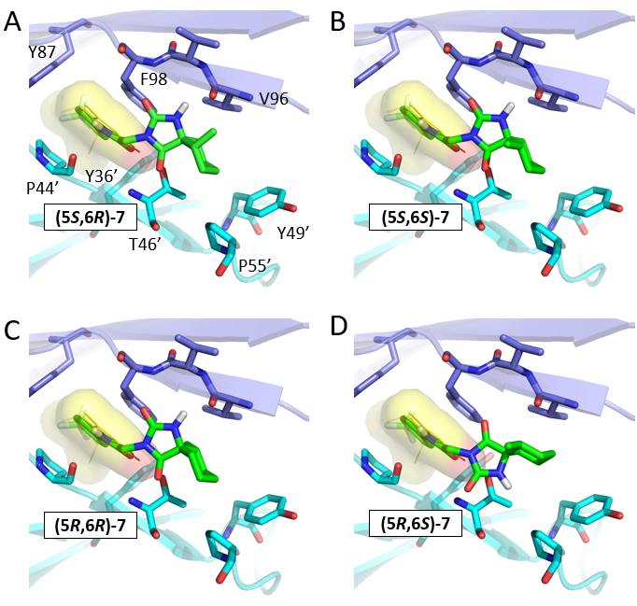
Figure S1. Models of each stereoisomer of compound 7 docked to JTO-FL. The position of 1 in the crystal structure of JTO-FL•1 is shown as yellow sticks and as a surface representation. Autodock-generated poses of each small molecule are shown as green sticks.

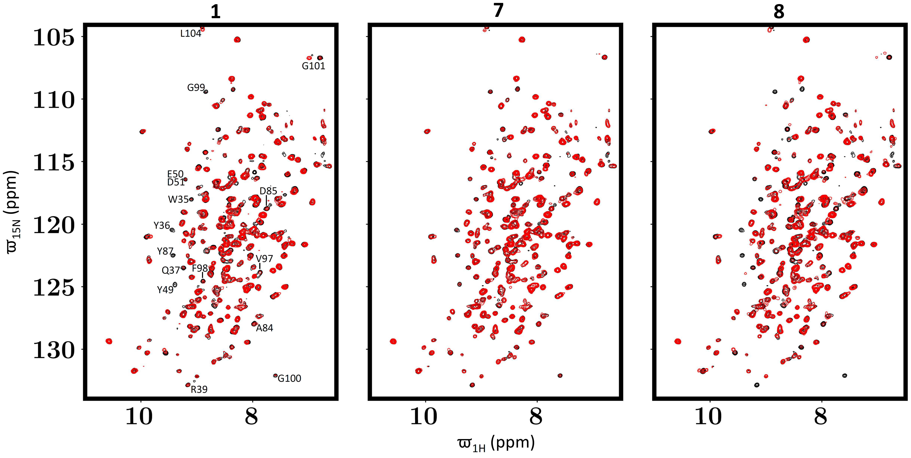
Figure S2. ¹⁵N-¹H HSQC NMR spectra of WIL-FL LC (50 µM) in the absence (black contours) and presence (red contours) of the indicated small molecule kinetic stabilizers (100 µM). The labeled black contours in the left panel denote peaks in the unbound WIL-FL that were perturbed by addition of small molecule kinetic stabilizers and correspond to residues near the V_{L}-V_{L} domain dimer interface comprising the kinetic stabilizer binding site (see Fig. 3 in main text).

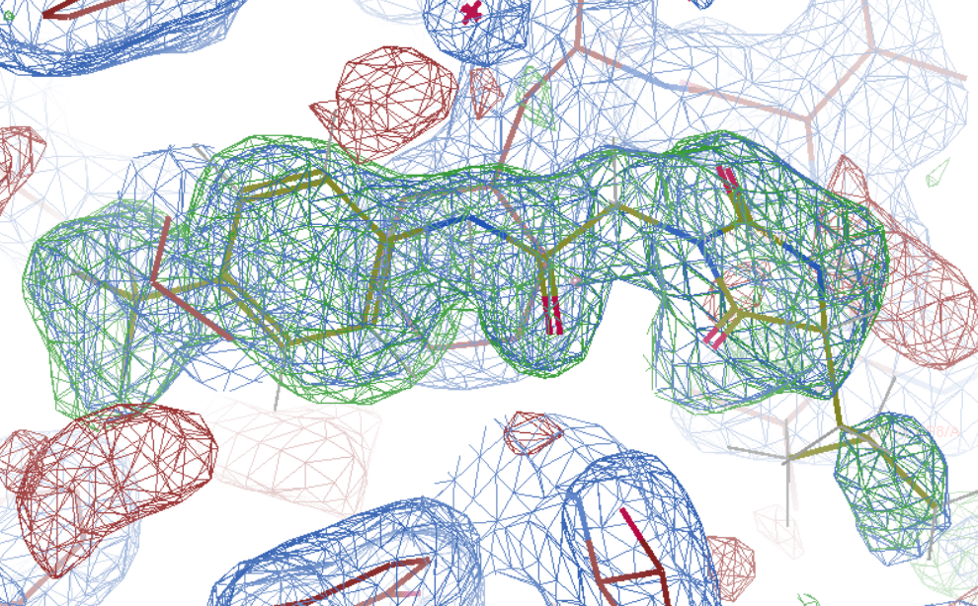
Figure S3. Omit electron density maps support the presence of 8 in the crystal structure of JTO-FL•8 complex. The omit map was generated by deletion of all atoms corresponding to 8. 2Fo-Fc (blue), positive Fo-Fc (green), and negative Fo-Fc (red) maps of the 8 binding site are shown, with the ligand modeled. The 2Fo-Fc and Fo-Fc maps are contoured at ± 1.0 σ and ± 3.0 σ, respectively.

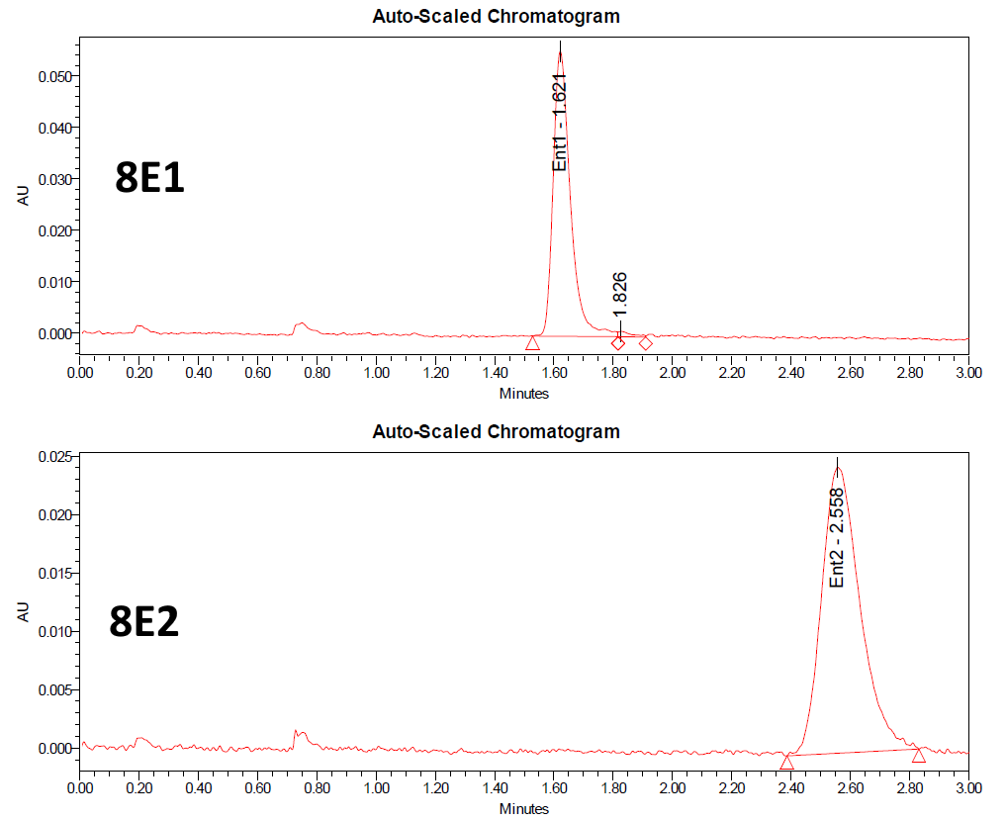
Figure S4. Supercritical fluid chromatography traces of isolated enantiomers of 8, denoted 8E1 and 8E2, after chiral separation.

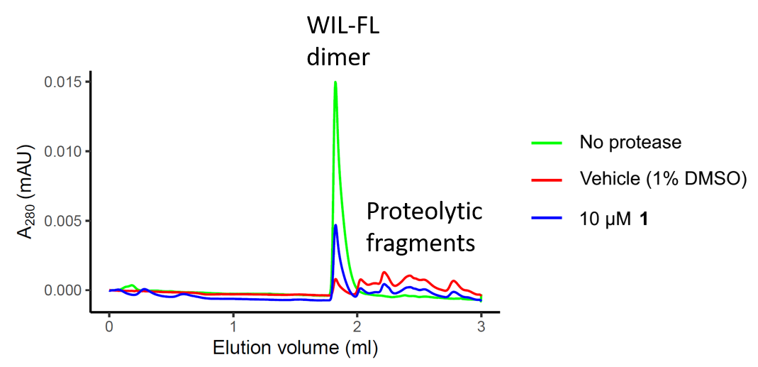
Figure S5. Example analytical size-exclusion chromatography traces of the WIL-FL dimer and proteolytic fragments. Cleavage of WIL-FL releases multiple fragments that have a longer elution time due to their smaller sizes compared to the parent dimer. Addition of small molecule stabilizer (e.g., 10 µM 1) protects WIL-FL from proteolysis.

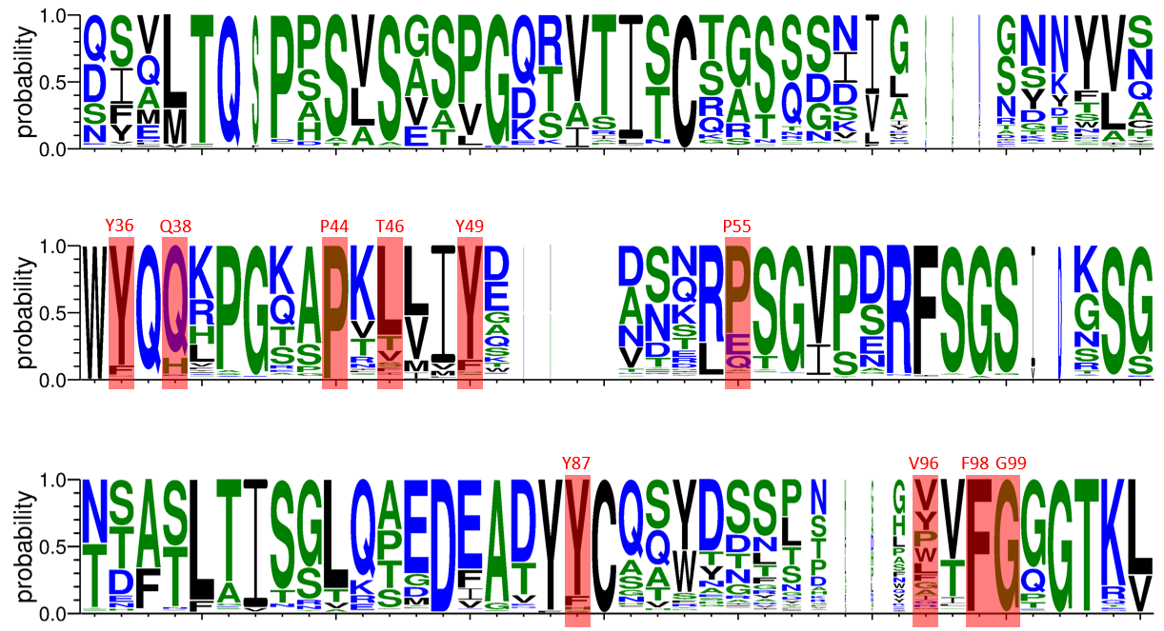
Figure S6. Sequence logo plot of 347 AL-associated LC V_{L}-domain sequences deposited in AL-Base [6]. Positions that comprise the binding sites of 1 or 8 in JTO-FL are highlighted in red. The identities and positions (Kabat numbering system) of highlighted residues in JTO-FL are denoted in red font. The logo plot was generated using WebLogo [7].

Supplementary References
1. Morgan, G.J. and J.W. Kelly, The Kinetic Stability of a Full-Length Antibody Light Chain Dimer Determines whether Endoproteolysis Can Release Amyloidogenic Variable Domains. J Mol Biol, 2016. 428(21): p. 4280-4297.
2. Rognoni, P., et al., A strategy for synthesis of pathogenic human immunoglobulin free light chains in E. coli. PLoS One, 2013. 8(9): p. e76022.
3. Forli, S., et al., Computational protein–ligand docking and virtual drug screening with the AutoDock suite. Nature Protocols, 2016. 11(5): p. 905-919.
4. Schuck, P., Size-distribution analysis of macromolecules by sedimentation velocity ultracentrifugation and lamm equation modeling. Biophys J, 2000. 78(3): p. 1606-19.
5. Morgan, G.J., et al., Stabilization of amyloidogenic immunoglobulin light chains by small molecules. Proc Natl Acad Sci U S A, 2019. 116(17): p. 8360-8369.
6. Bodi, K., et al., AL-Base: a visual platform analysis tool for the study of amyloidogenic immunoglobulin light chain sequences. Amyloid, 2009. 16(1): p. 1-8.
7. Crooks, G.E., et al., WebLogo: a sequence logo generator. Genome Res, 2004. 14(6): p. 1188-90.

