Fractional enrichment of proteins using [2-¹³C]-glycerol as the carbon source facilitates measurement of excited state ¹³Cα chemical shifts with improved sensitivity

Alexandra Ahlner¹, Cecilia Andresen¹, Shahid N. Khan¹, Lewis E. Kay^{2,3} and Patrik Lundström^{1,*}

¹Division of Molecular Biotechnology, Department of Physics, Chemistry and Biology, Linköping University, SE-58183 Linköping, Sweden

²Departments of Molecular Genetics, Biochemistry and Chemistry, The University of Toronto, One King’s College Circle, Toronto, Ontario M5S 1A8, Canada

³Hospital for Sick Children, Program in Molecular Structure and Function, 555 University Avenue, Toronto, Ontario, M5G 1X8, Canada

Supporting information

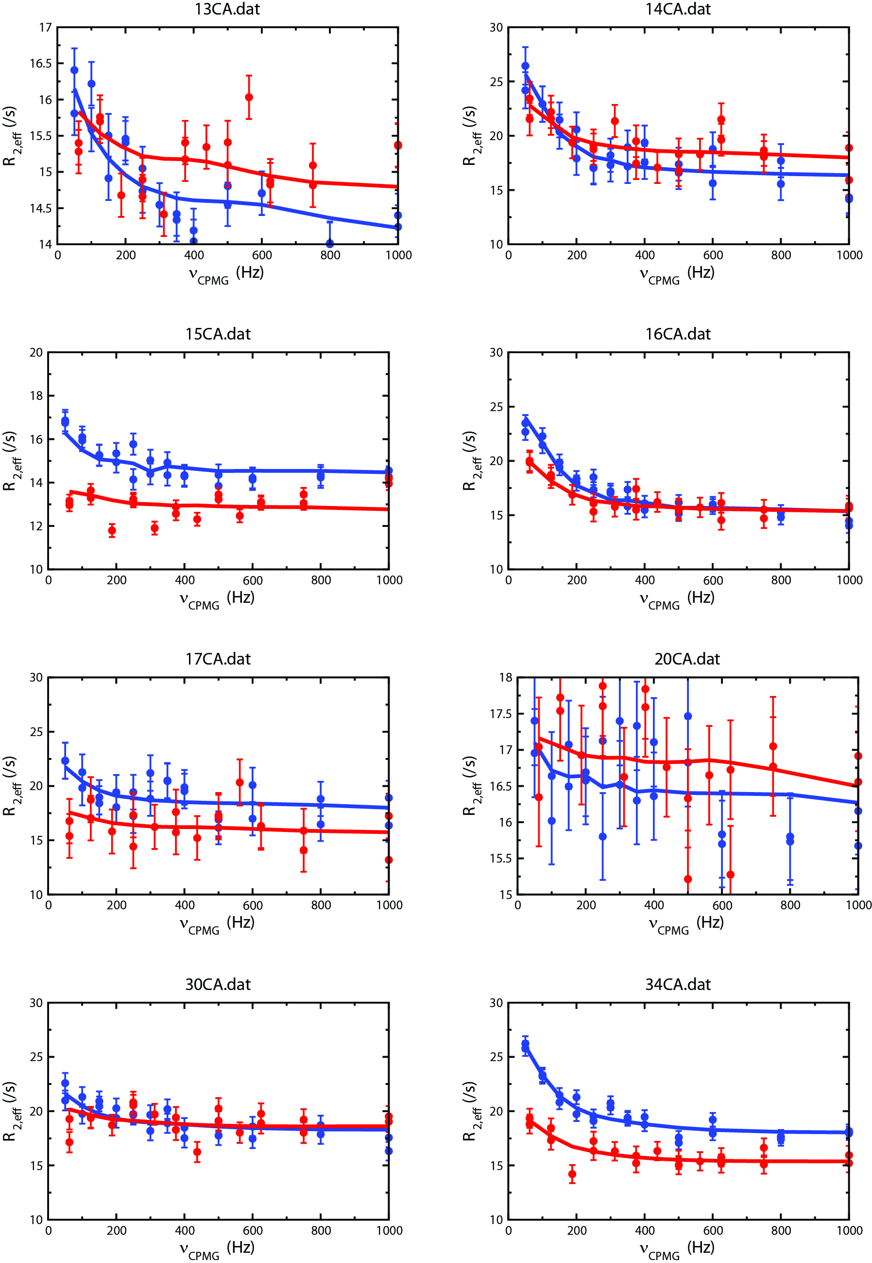

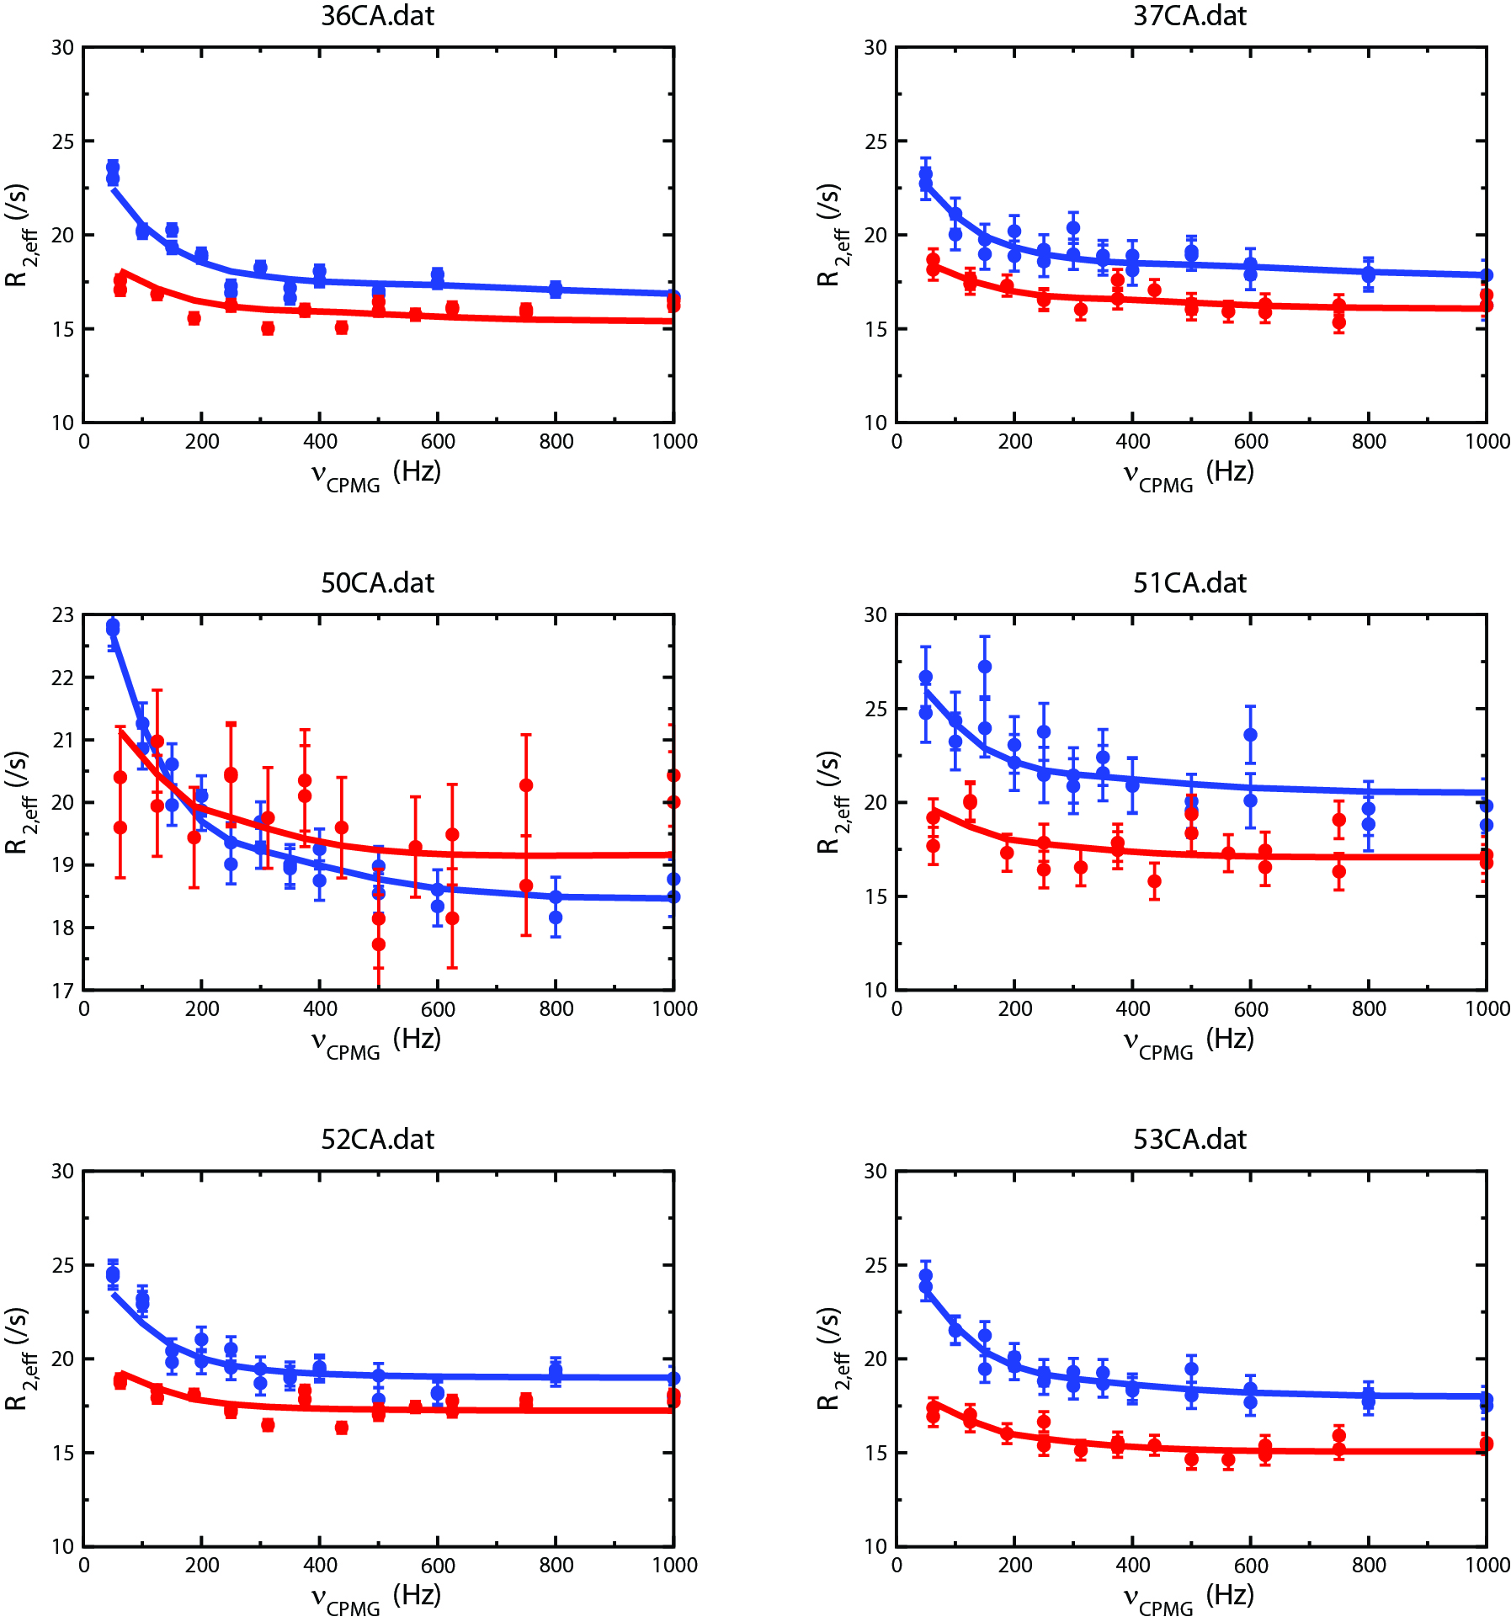

Figure S1. ¹³Cα dispersion profiles for all residues with significant chemical exchange in an Abp1p SH3 domain that interconverts between free and Ark1p peptide bound forms (≈5% bound Ark1p peptide is present). The SH3 domain was produced with [2-¹³C]-glycerol as the sole carbon source. Red (blue) symbols denote data points recorded at 14.1 (18.8) T, 25°C, and the solid lines are a global fit to the data, assuming a model of two-site chemical exchange.
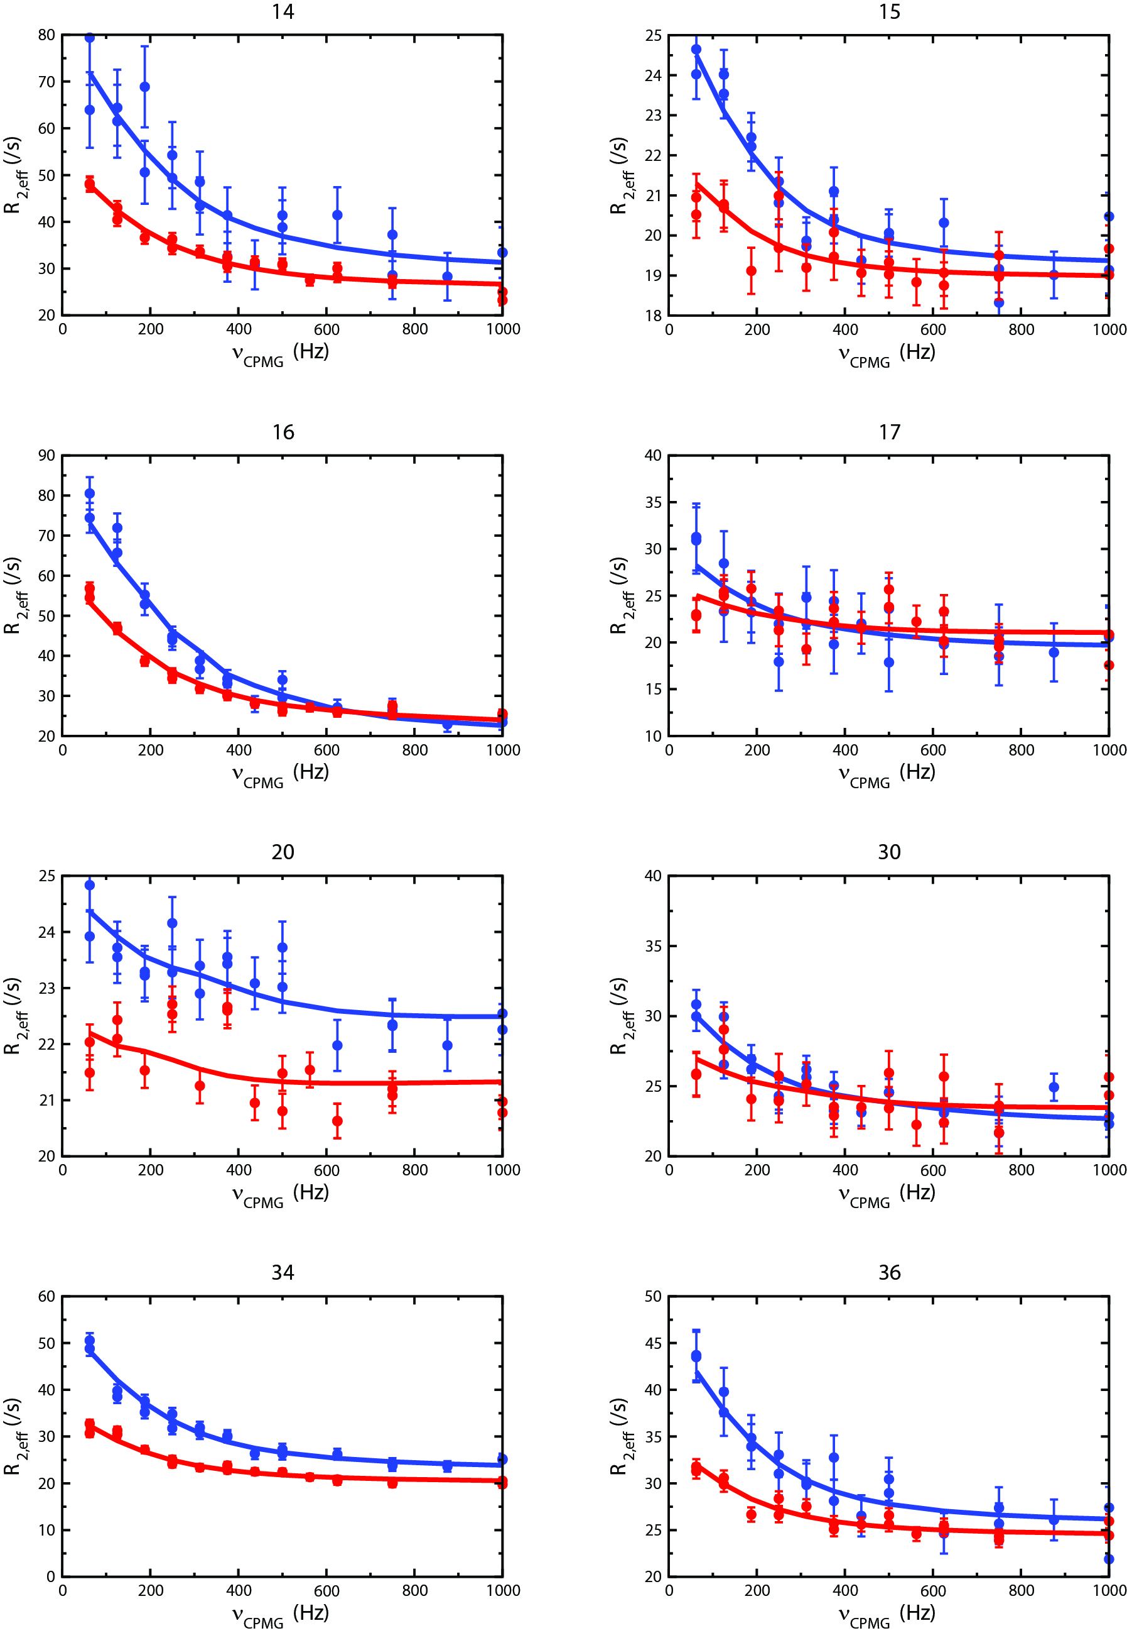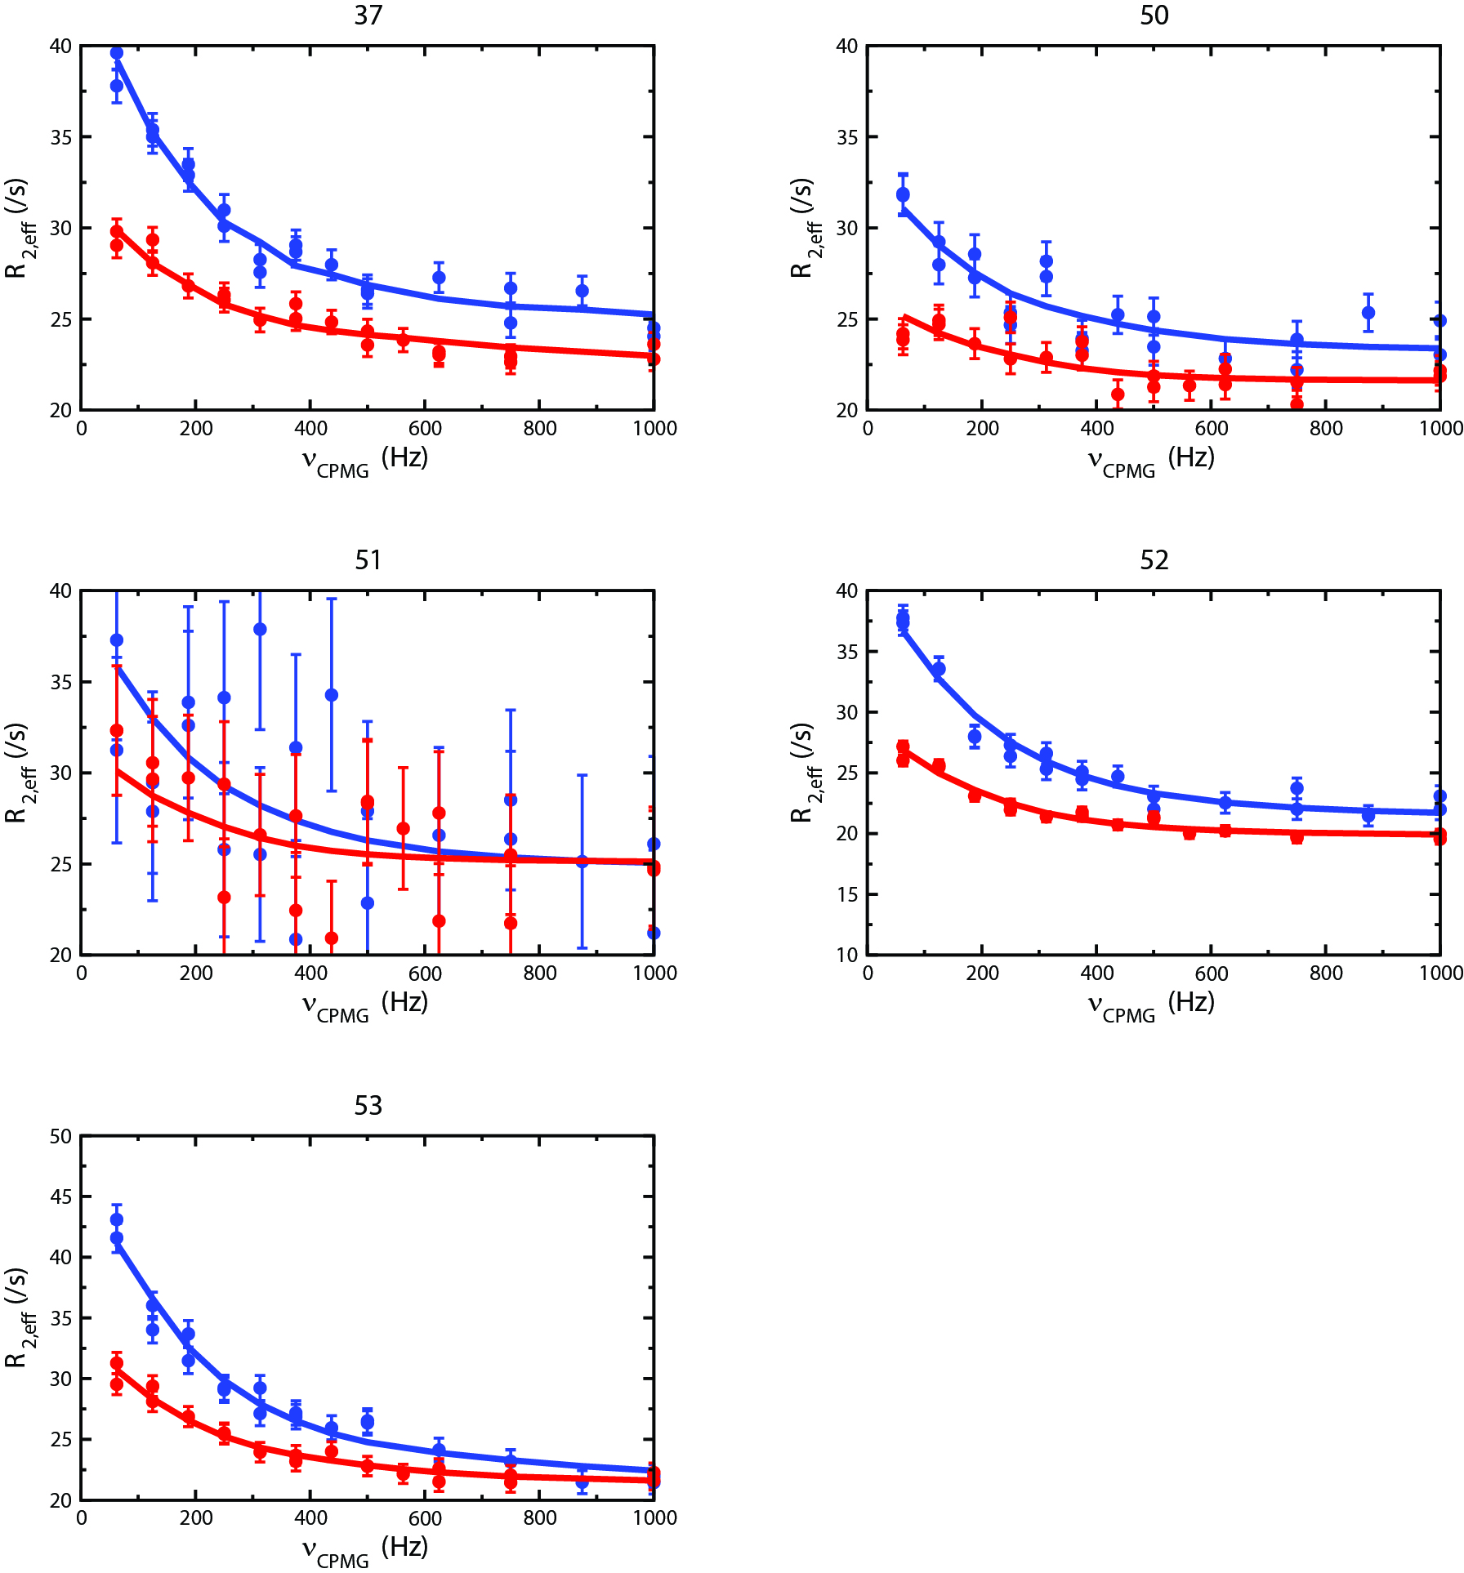

Figure S2. ¹³Cα dispersion profiles for all residues with significant chemical exchange in an Abp1p SH3 domain that interconverts between free and Ark1p peptide bound forms (≈90% bound Ark1p peptide is present). The SH3 domain was produced with [2-¹³C]-glycerol as the sole carbon source. Red (blue) symbols denote data points recorded at 14.1 (18.8) T, 25°C, and the solid lines are a global fit to the data, assuming a model of two-site chemical exchange.

